VEDANTH S 231901060

**Exp No:6 Customize Switch with Network Modules using Cisco Packet Tracer**

**Date:27.08.24**

# Aim:

To Customize Switch with Network Modules using Cisco Packet Tracer

# Open Cisco Packet Tracer

* + Launch Cisco Packet Tracer on your computer.

# Add a Switch to Your Workspace

* + In the device toolbar (usually on the left side of the screen), locate the "Switches" section.
  + Drag and drop a switch model onto the workspace. For instance, you might choose a model like the "2950" or "2960."



# Access the Switch’s Physical Layout

* + Click on the switch in the workspace to open its configuration window.
  + Navigate to the "Physical" tab to see the switch's physical layout and modules.

# Add Network Modules

* + In the "Physical" tab, you might see options to add or modify network modules.
  + Click on the slot where you want to add a module.
  + Drag the module from the list of available modules and drop it into the slot on the switch.

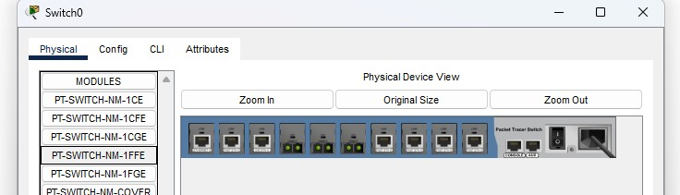

# Configure the Modules and save the configuration

* + After adding the module, switch to the "Config" tab in the switch’s configuration window.
  + Here, you can configure the ports provided by the module. For example, you can set IP addresses, VLAN configurations, and other settings for the new interfaces.

# Config the hostname of the switch

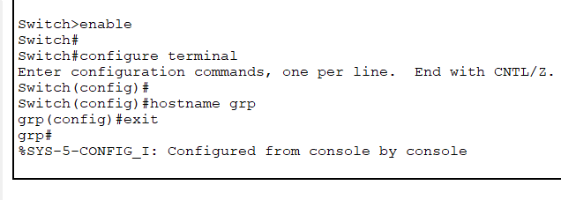

**Set the message of the day(MOTD) banner for the switch**

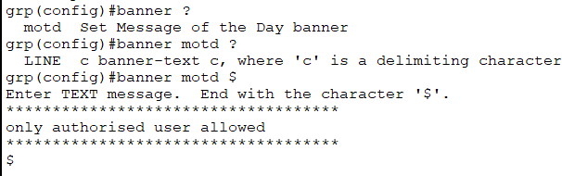

# Config the line console password and enable secret password

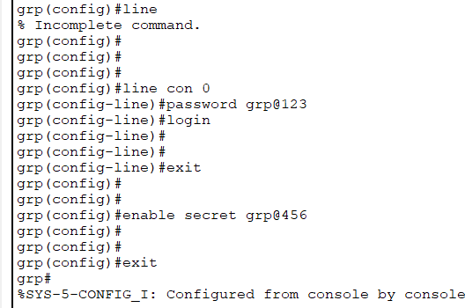

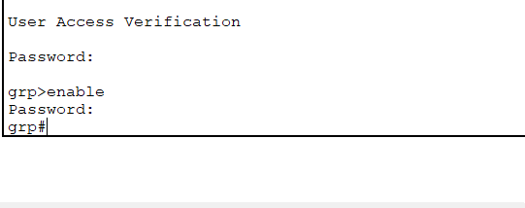

**Show the Vlan**

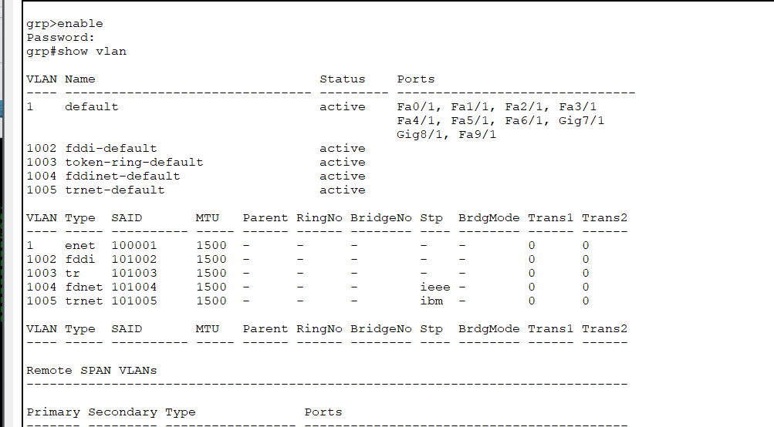

# Naming the VLAN

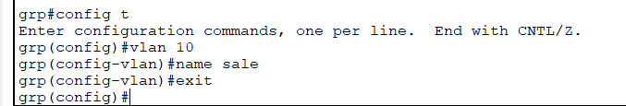

**Assign Interface to VLAN**

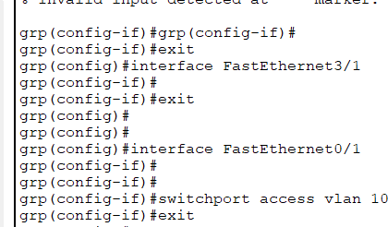

# Assign IP address to VLAN

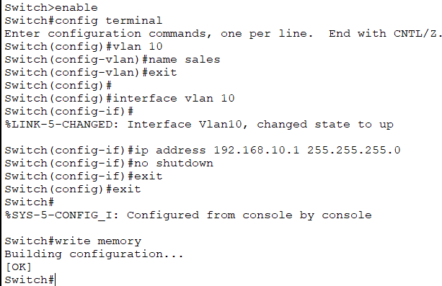

**Result:**

Thus successfully configured and customize switch with network modules using cisco packet tracer has been verified .